III Computer modeling

What is a computer Model
Computer modeling is the use of computers to model objects and to simulate processes.
Computer models are valuable because they:
- Allow a person to study the response of a system to conditions that are not easily or safely applied in a real situation.
- Can be speed up or slowed down. A model can also allow an observer to study how the functioning of an entire system can be altered by changing individual components of the system.

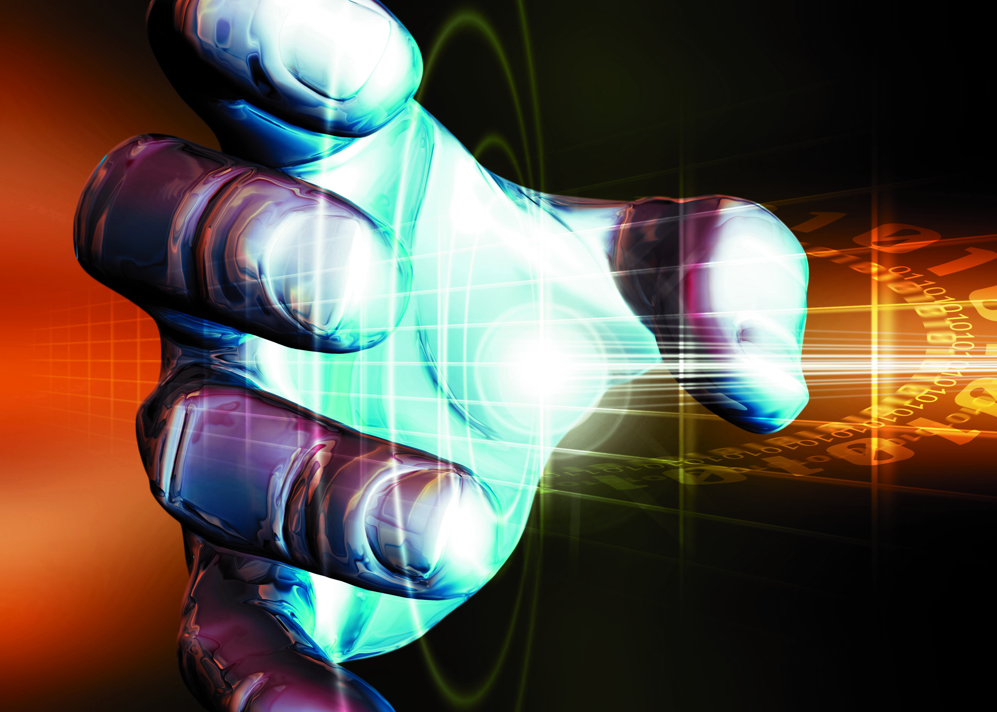
Human hand computer Model

Types of computer Models

Economic models
Those are now used to study economic growth, employment, energy and food resources, population, and housing needs, on a world scale as well as on a local level.

Medical Models
In the medical field, computer models are used to develop new drugs and to predict their effects on the body. Three-dimensional models of human organs are used to teach anatomy and biology to medical students, with the advantage that the student can manipulate the computer model like a real object, while graphics and animation reveal otherwise hidden information. Neural networks, computer approximations of the brain's neural architecture, aid researchers in understanding brain functions.
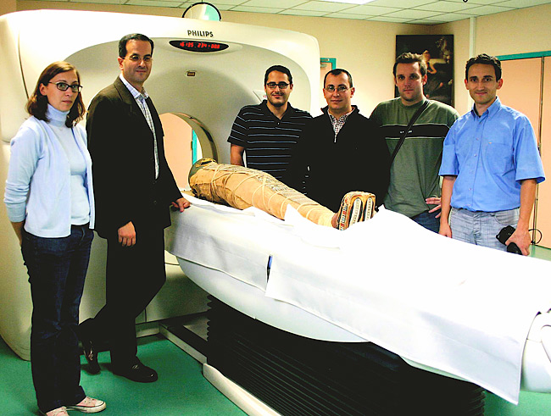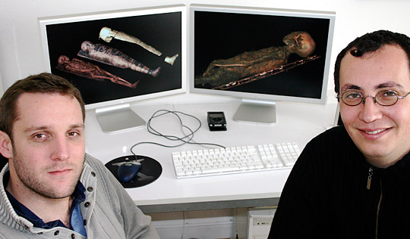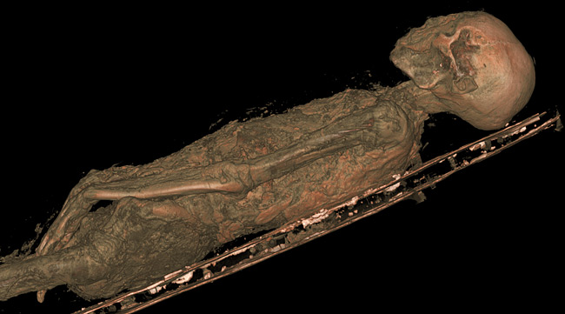

Engineering Models
Most designs are developed and tested with a computer model . With interactive computer-aided design, engineers draw and redraw designs quickly and inexpensively. Not only does the computer aid in the design, it also allows the user to study the response of the designed product to factors such as physical stress. The engineer can also study the effects of different materials on physical properties, and the effects of different designs on cost.

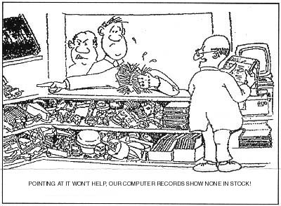

Business Models,
Spreadsheet programs are simple and inexpensive computer models that are widely applicable, especially when accompanied by graphs and charts. As an example, they can be used to study how changes in levels of sales and prices effect a company's profits.
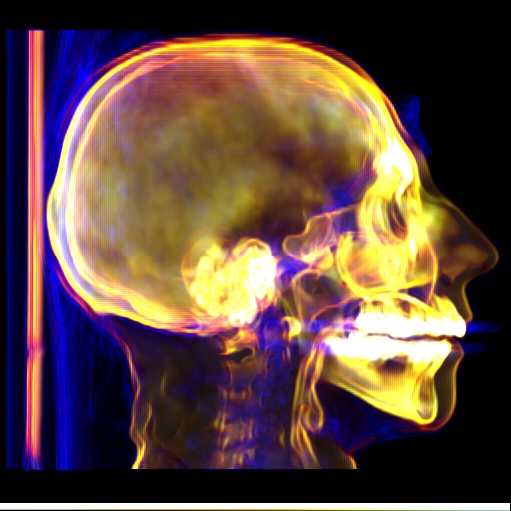

How Computer models are built:
- A computer model is usually defined in mathematical terms with a computer program .
- Mathematical equations are constructed that represent functional relationships within a system.
- When the program is running the mathematical dynamics become analogous to dynamics of the real system.
- Results are given in the form of data.
- Some types of model involve a computer graphics representation of an object, which can be manipulated on a video display terminal in much the same way that a three-dimensional clay or wood model might be manipulated.
- The success of computer models is highly dependent on the mathematical representations of systems and on chosen input parameters.
- For many systems, graphical or mathematical representations are extremely complex because there are so many factors present. Factors are often represented as sub-models, and interact with each other. Input parameters consist of conditions that are known at the beginning of a modeling sequence and often have to be estimated.

Computer 3D approach
Many uses of computer graphics, such as computer animation, computer-aided design and manufacturing (CAD/CAM), video games, and scientific visualization of data such as magnetic resonance images of internal organs, require drawing three-dimensional (3D) objects on the computer screen. The drawing of 3D scenes, called rendering is usually accomplished using a pipeline or assembly-line approach, in which several program instructions can, at any given time, be executed in various stages on different data.
This graphics pipeline is implemented either with special-purpose 3D graphics microprocessors (hardware) or with computer programs (software). Hardware rendering can be expensive, but it enables the user to draw up to 60 images per second and to make immediate changes to the image. Rendering software are very slow, requiring from a few minutes to a full day to render a single image. However, computer animation almost always uses rendering software because they provide greater control of the images and potentially photo-realistic quality.

3D Models Creation stages:

A. Modeling
The first step in a rendering pipeline is the creation of 3D objects. The surface of an object, such as a sphere, is represented either as a series of curved surfaces or as polygons, usually triangles. Their spatial coordinates represent the points on the surface of the object, called vertices, in the computer. Other characteristics of the model, such as the color of each vertex and the direction perpendicular to the surface at each vertex, called the normal, also must be specified. Since polygons do not create smooth surfaces, detailed models require a large number of polygons to create an image that looks natural.
Another technique used to create smooth surfaces relies on a parametric surface, a two-dimensional (2D) surface existing in three dimensions. For example, a world globe can be considered a 2D surface with latitude and longitude coordinates representing it in three dimensions. More complex surfaces, such as knots, can be specified in a similar manner.

B. Transformation
Once these models have been created, they are placed in a computer-generated background. For example, a rendered sphere might be set against a backdrop of clouds. User instructions specify the object's size and orientation. Then the colors, their locations, and the direction of light within the computer-generated scene, as well as the location and direction of the viewing angle, are selected.
At this point, the computer program generally breaks up complex geometric objects into simple "primitives," such as triangles. Next, the renderer determines where each primitive will appear on the screen by using the information about the viewing position and the location of each object scene.

C. Lighting and Shading
Once a primitive has been located, it must be shaded. Shading information is calculated for each vertex based on the location and color of the light in the computer-generated scene, the orientation of each surface, the color and other surface properties of the object at that vertex, and possible atmospheric effects that surround the object, such as fog.
Graphics hardware most commonly uses Gouraud shading, which calculates the lighting at the vertices of the primitive, and interpolates, or blends, colors across the surface to make the object appear more realistic. Phong shading represents highlights by blending the lighting and colors in a direction perpendicular to the surface at each vertex, the normal, and calculating the lighting at each pixel. This provides a better approximation of the surface but requires more calculation.

D. Mapping
Several techniques permit the artist to add realistic details to models with simple shapes. The most common method is texture mapping, which maps or applies an image to an object's surface like wallpaper. For example, a brick pattern could be applied to a rendered sphere. In this process only the object's shape, not features of the texture, such as the rectangular edges and grout lines of the brick, affect the way the object looks in lighting; the sphere still appears smooth. Another technique, called bump mapping, provides a more realistic view by creating highlights to make the surface appear more complex. In the example of the brick texture, bump mapping might provide shadowing in the grout lines and highlights upon some brick surfaces. Bump mapping does not affect the look of the image's silhouette, which remains the same as the basic shape of the model. Displacement mapping addresses this problem by physically offsetting the actual surface according to a displacement map. For example, the brick texture applied to the sphere would extend to the sphere's silhouette, giving it an uneven texture.

E. Blending
Once the shading process has produced a color for each pixel in a primitive, the final step in rendering is to write that color into the frame buffer. Frequently, a technique called Z buffering is used to determine which primitive is closest to the viewing location and angle of the scene, ensuring that objects hidden behind others will not be drawn. Finally, if the surface being drawn is semitransparent, the front object's color is blended with that of the object behind it.

F. Physically Based Rendering
Because the rendering pipeline has little to do with the way light actually behaves in a scene, it does not work well with shadows and reflections. Another common rendering technique, ray tracing, calculates the path that light rays take through the scene, starting with the viewing angle and location and calculating back to the light source. Ray tracing provides more accurate shadows than other methods and also handles multiple reflections correctly. Although it takes a long time to render a scene using ray tracing, it can create stunning images.

Computer-Generated 3-D Models
Graphic designers and scientists use computers to create 3-D computer graphics using a process called rendering. In this case, the term 3-D refers not to stereoscopic images, but to graphics rendered with highly accurate shape, shading, and perspective using mathematical calculations on a computer. The computer mathematically derives how an object should appear to a viewer from all angles in a given set of conditions.
The first step in rendering requires the user to provide the computer with a detailed description of an object. This description can be delivered to the computer in the form of photographs or video images, or it can be created from scratch by means of a software program . The computer calculates a viewer's perspective of the object from all angles and uses this information to create a wire-frame representation, in which every surface on the object is represented by a geometric shape.
Next, the user instructs the computer to fill the surfaces of the geometric shapes with colors, textures, and patterns that give the object a more realistic quality. Finally, the user provides the computer with detailed information about the source and angle of the lighting. From this information, the computer determines the way the light would hit each surface on the wire-frame representation and adds appropriate reflections and shadows.
Hollywood filmmakers first used 3-D computer graphics in movie shorts in the 1970s but did not apply the techniques to a major feature film until 1982 in the science fiction hits Star Trek: The Wrath of Khan and Tron. Techniques for 3-D computer animation rapidly grew more sophisticated and more common. In 1995 Toy Story became the first feature film in which all of the images were created entirely with computers.
Today, 3-D computer graphics have applications in industrial design, medical research, and many other fields. In computer-aided design and manufacturing (CAD/CAM), industrial engineers use computers to build 3-D models of complicated products, such as airplanes and automobiles. Computer-generated maps show topographical features on the surface of Earth and other planets. Medical researchers study 3-D models of cells, molecules, organs, and even the entire human body. Other applications of 3-D computer models include diagnostic eadiology pharmaceutical research, and much more.
Among the fastest growing uses for 3-D computer graphics are computer games that enable players to manipulate 3-D graphics on-screen. These games incorporate highly sophisticated real-time rendering tools that process player input and update the graphics immediately. Real-time rendering tools update computer graphics 30 or more times per second, making them appear to move in the time-frame in which events would naturally happen in the real world.

Review Questions:
- Define three of the following terms: model – simulation – computer model – mapping - blending
- How can models be used?
- When does a model become a simulation?
- List elements behind the philosophy of modeling?
- Describe the two principles of modeling?
- Discuss the processes of modeling and modeling practice
- Explain time management factors related to modeling?
- Discuss two only of the following major fields of modeling:
- Physical modeling
- Behavioral modeling
- Environmental modeling
- Multi-resolution modeling
- Discuss the concepts of modeling verification, validation, and accreditation?
- Explain the role of artificial intelligence in behavioral modeling ?
- Describe two application fields of models?
- Describe some of the different types of 3d graphic illustrating their usefulness?
- Identify the computer 3d approach?
- How computer models are built?
- List types computer-generated 3-d models
- State 3d models creation stages?
- Describe major steps of computer graphics making using the computer?

