Model Types:
Below we identify 4 types of models for discussion and reference. In practice a well developed model of a real-world system will likely contain aspects of each individual model type described here.
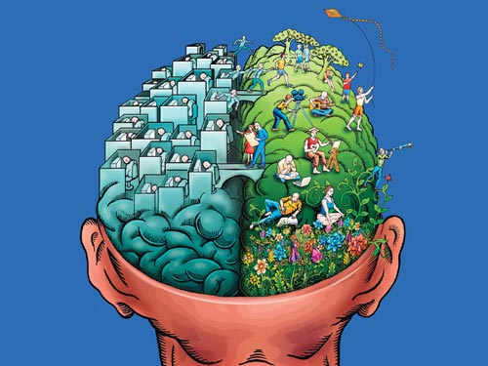
Figure 2 conceptual model

Conceptual Models: are qualitative models that help highlight important connections in real world systems and processes. They are used as a first step in the development of more complex models.

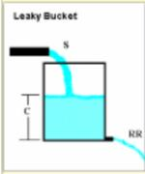
Figure 3

Interactive Demonstrations Interactive demonstrations are physical models of systems that can be easily observed and manipulated and which have characteristics similar to key features of more complex systems in the real world.
The following set of models can help bridge the gap between conceptual models and models of more complex real world systems.

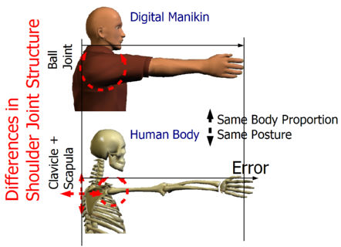
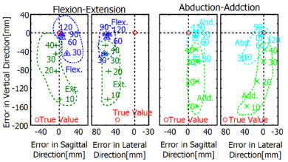
Figure 4 Analytical ergonomic model
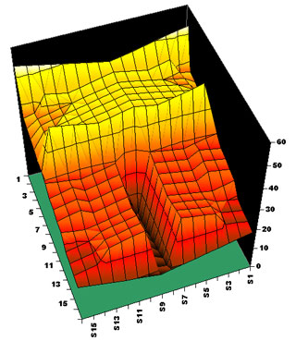
Figure 5 Statistical model

Mathematical and Statistical Models involve solving relevant equation(s) of a system or characterizing a system based upon its statistical parameters such as mean, mode, variance or regression coefficients.
Mathematical models include Analytical models and Numerical Models. Statistical models are useful in helping identify patterns and underlying relationships between data sets.
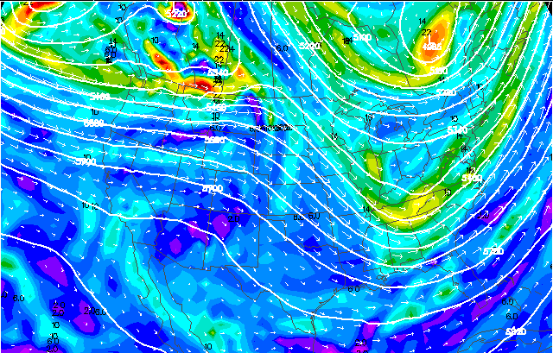Figure 6 Environmental model

Visualization models By this we mean anything that can help one visualize how a system works. A visualization model can be a direct link between data and some graphic or image output or can be linked in series with some other type of model so to convert its output into a visually useful format. Examples include 1-D, 2-D, and 3-D graphics packages, map overlays, animations, image manipulation and image analysis.
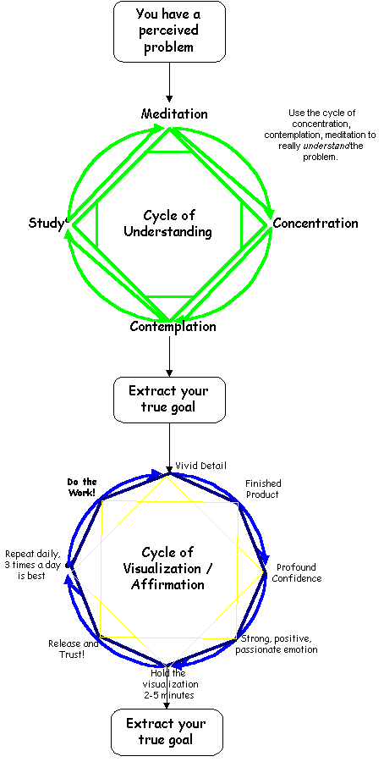

What is Visualization?
Visualizations can present massive amounts of information to help scientists identify relevant patterns and processes in nature. Data visualization techniques range from simple pie charts or x-y scatter plots to colorful contour plots and 3-D images that can be manipulated and viewed from a variety of orientations and with a variety of color schemes. Spreadsheets like Excel have good basic graphing capabilities which are in essence visualizations. We have discussed the use of Excel for graphing data and model output in several examples. Our primary focus here will be the more sophisticated visualizations, which allow one to visualize multidimensional data.

Typically, visualizations for multidimensional data sets allow the users to:
- Select a particular subset of a data set in space and/or time;
- Create 3-D and contour plots;
- View data from different orientations;
- Create and view animations of data at different rates;
- Customize the color enhancement of images to highlight features of particular interest;

What Are Conceptual Models
People receive information, process this information, and respond accordingly many times each day. This sort of processing of information is essentially a conceptual model (or mental model) of how things in our surrounding environment work.
Several short examples of conceptual models can help better define them.
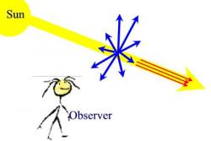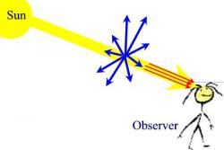
Figure 7

Red sun-sets and blue skies. The intensity of scattered light from the atmosphere increases with decreasing wavelength. In fact the intensity of scattered light is inversely proportional to the 4th power of wavelength. [The intensity of 450 nm blue light is more than 4 times larger than that of 650 nm red light]. The observer on the left sees a blue sky when looking up and the observer on the red sees a reddish sun. More detail can be given and this can be extended into a mathematical model. However for many introductory atmospheric science classes this is a good starting point.
This argument in favor of a significant carbon tax is another example of a mental model. At present the cost of fossil fuel combustion does not include the direct health costs associated with respiratory ailments linked to photochemical smog in urban areas or the costs associated with other environmental problems such as acid rain or possible long-term climate changes. A significant carbon tax will better reflect the true cost of fossil fuels to the citizens; pay at the pump now or pay taxes later to support increased demands on the health care system. Such a carbon tax will increase the cost of fossil fuel energy sources making alternative energy sources like solar, wind, hydrogen fuel cells, and tidal more economically competitive. This will help shift our economy from its near exclusive use of fossil fuels towards cleaner more efficient fuels, which will ultimate cut global carbon emissions. The reduced carbon emissions will help curtail the buildup of carbon dioxide in the atmosphere. In addition, other harmful byproducts of fossil fuel combustion, particularly in urban areas, will be reduced.

Mathematics and Statistics Models

What are Mathematical and Statistical Models
These types of models are obviously related, but there are also real differences between them.
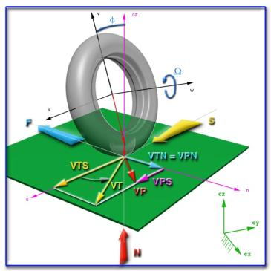
Figure 7

Mathematical Models:
grow out of equations that determine how a system changes from one state to the next (differential equations) and/or how one variable depends on the value or state of other variables (state equations) These can also be divided into either numerical models or analytical models.
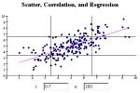
Figure 8

Statistical Models:
include issues such as statistical characterization of numerical data, estimating the probabilistic future behavior of a system based on past behavior, extrapolation or interpolation of data based on some best-fit, error estimates of observations, or spectral analysis of data or model generated output.
As a way to clarify the above ideas, here is an example of the development of a simple mathematical model.

Why use mathematical and statistical models?
Mathematical and Statistical models can be used to help students obtain a better grasp on a variety of topics.
How can these models be used effectively in class?
In addition to the general discussion about how to use models effectively, there are a number of considerations, both pedagogical and technical, that have to do with using mathematical and statistical models specifically.
Building the Quantitative Skills of Students in Design Courses: This special issue (v48 n4, edited by Macdonald, Srogi, and Stracher) of the Journal of Design Education has several examples of how mathematics and statistics can be used in design courses.

Numerical Models
Numerical models are mathematical models that use some sort of numerical time-stepping procedure to obtain the models behavior over time. The mathematical solution is represented by a generated table and/or graph.
For example,
A model of personal savings that assumes a fixed yearly growth rate, r, in savings (S) implies that time rate of change in saving d(S)/dt is given by,
d(S)/dt= r (S) eqn. 1
(this example is also used to discuss analytical models so that numerical and analytical models can be compared and contrasted more easily).
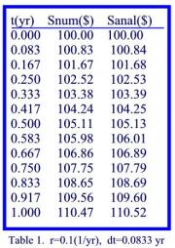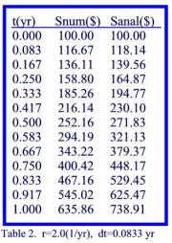
An example of a numerical solution to this fundamental differential equation is given shown in Table 1 along with the corresponding values from the analytical solution, S=SoEXP(rt).
The numerical values in the Table 1 are generated by using the difference equation,
S(t+dt) = S(t) + d(S) = S(t)+ r S(t) dt = S(t) [1+ r dt] eqn. 2
and assuming r=0.10 (1/yr) and a time step, dt, of one month (0.083 yr) for illustration. Since the change in savings, d(S), is rather small each time step this numerical solution agrees fairly well with the analytical solution.
Table 2 compares numerical and analytical results for r=2.0 (1/yr) and dt=0.083 yr). After 1 year there is a significant discrepancy between the numerical solution and the analytical (exact) solution. A smaller time step would be required to get better agreement between the numerical solution and the analytical solution. Using a time step of 0.01 yr gave a savings value of $724.46 with 100 numerical calculations compared with the exact result of $738.91.
This highlights a drawback of numerical solutions to model equations; to get good results many iterative calculations may be required. With fast computer speeds available today this is not really an issue for most model equations that one would explore in an introductory design course. In addition, the precision can be greatly improved for a given time step by using a numerical procedure which is more sophisticated than the rather simple Euler's method described by eqn 2.
Numerical solutions have several advantages over analytical solutions. First, the equations are much more intuitive. Students can clearly understand the meaning of eqn 2 and can generate Table 1 by hand or by using Excel. The exponential form of the analytical solution is clear to those with strong mathematics skills but not so clear to others. Second, the basic procedure S(t+dt) = S(t) + d(S) is the same regardless of how complicated the formulas are which describe d(S). This is not true of analytical solutions as it is relatively easy to get into mathematics which is much too complicated to obtain analytical solutions. Thus more realistic models of greater complexity can be investigated using numerical techniques.
For introductory design courses regardless of whether one uses analytical solutions or numerical solutions to model equations students should still use graphical output, animations, and tabular data to interpret, understand, and explain model behavior. There are three primary venues for introductory design models Excel, Stella II, and JAVA type interactive web based activities. Excel is great for graphing and exploring analytical models and can be used quite successfully for numerical solutions (this may involve copying your basic formulas down to hundreds of rows). Stella only uses numerical procedures and it has some options for which numerical procedure to use. JAVA type interactive Web activities use graphical output, animations, and tabular data to display the results of solving the model equations and hence the question of whether the programmer used an analytical or numerical solution becomes academic.
Other Information This site about Euler's Method (more info) uses an exponential growth model similar to ours. It has an interactive JAVA type graph that lets one explore the effects of time step variations on the solution.

Analytical Models
Analytical models are mathematical models that have a closed form solution, i.e. the solution to the equations used to describe changes in a system can be expressed as a mathematical analytic function.
For example,
A model of personal savings that assumes a fixed yearly growth rate, r, in savings (S) implies that time rate of change in saving d(S)/dt is given by,
d(S)/dt= r (S) eqn. 1
(This example is also used to describe numerical models so that numerical and analytical models can be compared and contrasted more easily).
The analytical solution to this differential equation is
S=So EXP(r t) eqn. 2
Where So is the initial savings, t is the time, and EXP (x) is Euler's number, e, raised to the power x. This equation is the analytical model of personal savings with fixed growth rate.
Are analytical models superior to numerical models? This may or may not be the case for introductory design students. Some argue that analytical models are more aesthetically pleasing since an inspection of the mathematical function can give information about the system's behavior without the need for graphing or generating a table of values. This argument assumes that the person looking at the model has a command of mathematics, which may not be true for some introductory design students.
Although the solution to the above simple system is fairly transparent, analytical solutions to equations describing more complex systems can often become fairly complicated. However, for those comfortable with mathematics an analytical solution does provide a concise preview of a model's behavior that is not as readily available with a numerical solution. Also implicit in the argument of an analytical model's superiority to numerical models is that graphing is tedious. This may have been the case 30 years ago but is certainly not true now. Regardless of whether one obtains an analytical solution or a numerical solution to a mathematical model, graphs showing the system's behavior over time and its sensitivity to variations in key model parameters are essential for student understanding. One disadvantage of analytical solutions is that they are often very mathematically challenging to obtain.

Other resources
Limited and Unlimited Growth (more info) This site discusses exponential growth and limited growth. It has an interesting JAVA type interactive applet at the bottom which is likely driven by the analytical solution to the logistic equation.
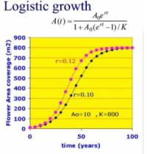
Figure 9

Interactive Demonstrations
This system is created by Dorothy Merritts, Robert Walter (Franklin & Marshall College) and Bob MacKay (Clark College)
• Interactive Lectures
Interactive demonstrations strengthen students' abilities to observe, and stimulate questions and discussions. A demonstration can be used in its simplest form as a show-and-tell experience to enhance a lecture, or it can be developed as an effective hands-on, inquiry-based learning opportunity in a class or lab. Interactive demonstrations can also be used in classes of all sizes, as projection systems can make demonstrations visible to students in the backs of large classrooms.
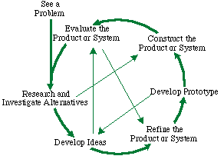
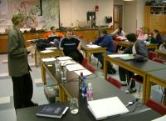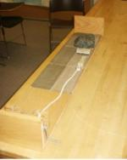
Figure 10
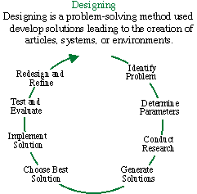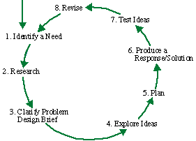
Interactive Demonstrations are physical or conceptual models that replicate part of a system of interest. Often they are constructed out of material or objects that are familiar to students in their everyday lives. It's always fun for students to see something familiar to them used in an unique and unexpected way.
For example, a lecturer in a given educational situation uses the "friction rock" to discuss ideas related to fault slip and earthquakes. The demonstration consists of a rock attached to a crank with a rope. The rock sits atop sandpaper and as the crank is turned, the pull on the rock increases until it overcomes the friction and the rock slides or jumps along the sandpaper.

Why Use Interactive Demonstrations
Interactive Demonstrations have proven to be very useful in addressing student's misconceptions as well as providing stimulating hands-on inquiry into simple parts of complex systems.

How to Use Interactive Demonstrations in Class
Like any type of in-class activity, Interactive Demonstrations require planning and setup in order to live up to their potential to improve student learning.

Applications of Models:
The variety of computer models increased as computers has become larger and faster. The increasing powers of computers will make computer models ever more useful, for research, for business planning, and for personal applications. With new generations of supercomputers, it should become more feasible to construct more accurate models of extremely complex systems, such as the weather, stellar evolution, and fundamental particle interaction. However, right now, the major fields of modeling application are:

Physical Modeling
- Object Interaction. object modeling is be divided into two pieces, the physical and the behavioral. Object interactions, which are often viewed as 'physics based', characterize the physical models.
- Movement. objects are often very mobile and a great deal of effort can be given to the correct movement of ground, air, sea, and space vehicles across different forms of terrain or through various forms of ether.
- Sensor Detection. object are also very eager to interact with each other in both peaceful and violent ways. But, before they can do this they must be able to perceive each other through the use of human and mechanical sensors.
- Engagement. Encounters with objects of a different affiliation often require the application of combat engagement algorithms. There are a rich set of these available to the modeler, and new ones are continually being created.
- Attrition. Object and unit attrition may be synonymous with engagement in the real world, but when implemented in a computer environment they must be separated to allow fair combat exchanges. Distributed simulation systems are more closely replicating real world activities than did their older functional/sequential ancestors, but the distinction between engagement and attrition are still important.
- Communication. The modern design area is characterized as much by communication and information exchange as it is by movement and engagement. This dimension of the design situation has been largely ignored in previous simulations, but is being addressed in the new systems under development today.
- More. Activities on the design situation are extremely rich and varied. The models described in this section represent some of the most fundamental and important, but they are only a small fraction of the detail that can be included in a model.

Behavioral Modeling
- Perception. simulations have historically included very crude representations of human and group decision making. One of the first real needs for representing the human in the model was to create a unique perception of the design for each group, unit, or individual.
- Reaction. objects or units need to be able to react realistically to various combat environments. These allow the simulation to handle many situations without the explicit intervention of a human operator.
- Planning. Today we look for intelligent behavior from simulated objects. Once form of intelligence is found in allowing models to plan the details of a general operational combat order, or to formulate a method for extracting itself for a difficult situation.
- Learning. Early reactive and planning models did not include the capability to learn from experience. Algorithms can be built which allow units to become more effective as they become more experienced. They also learn the best methods for operating on a specific design or under specific conditions.

- Artificial Intelligence. Behavioral modeling can benefit from the research and experience of the AI community. Techniques of value include: Intelligent Agents, Finite State Machines, Petri Nets, Expert and Knowledge-based Systems, Case Based Reasoning, Genetic Algorithms, Neural Networks, Constraint Satisfaction, Fuzzy Logic, and Adaptive Behavior. An introduction is given to each of these along with potential applications in the design environment.

Environmental Modeling
Many environmental systems have been modeled. The effect on soil and water of chemical or nuclear contamination can be evaluated with a computer. A model of a river can show how using water for dams, irrigation, and power plants will affect the water flow at various points. Computer models can help in studying soil erosion and planning commercial use of forest land.
- Terrain. Systems are heavily dependent upon the environment in which they operate. The representation of terrain has been of primary concern because of its importance and the difficulty of managing the amount of data required.
- Atmosphere. The atmosphere plays an important role in modeling air, space, and electronic warfare. The effects of cloud cover, precipitation, daylight, ambient noise, electronic jamming, temperature, and wind can all have significant effects on design activities.
- Sea. The surface of the ocean is nearly as important to naval operations as is terrain to army operations. Sub-surface and ocean floor representations are also essential for submarine warfare and the employment of SONAR for vehicle detection and engagement.
- Standards. Many representations of all of these environments have been developed. Unfortunately, not all of these have been compatible and significant effort is being given to a common standard for supporting all simulations.
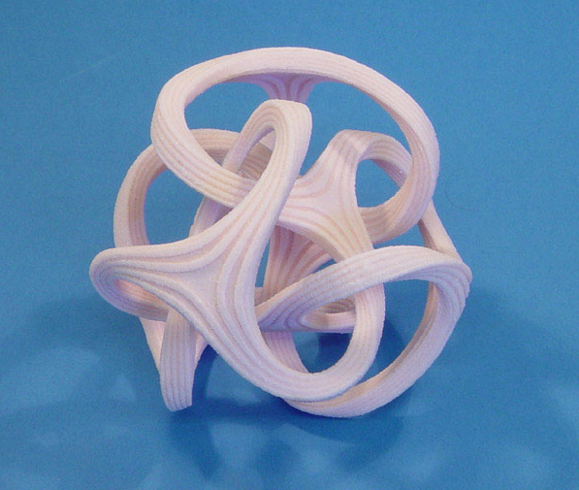

Multi-Resolution Modeling
- Aggregation. Designers have always dealt with design problems in an aggregate form. This has carried forward into simulations which operate at this same level, omitting many of the details of specific design details objects and events.
- Disaggregating. Recent efforts to join constructive and virtual simulations have required the implementation of techniques for cross the boundary between these two levels of representation. Disaggregating attempts to generate an entity level representation from the aggregate level by adding information. Conversely, aggregation attempts to create the constructive from the virtual by removing information.
- Interoperability. It is commonly accepted that interoperability in these situations is best achieved though disaggregating to the lowest level of representation of the models involved.
- Inevitability. Models are abstractions of the real world generated to address a specific problem. Since all problems are not defined at the same level of physical representation, the models built to address them will be at different levels. The modeling an simulation problem domain is too rich to ever expect all models to operate at the same level. Multi-Resolution Modeling and techniques to provide interoperability among them are inevitable.

