Modeling Course

Models can be one of two categories; physical and nonphysical. In each category lies a varied number of types. Let us review the following types of models:

Physical
- Physical model, a physical representation of an object
- Scale model, a replica or prototype of an object
- 3D modelling, a 3D polygonal representation of an object, usually displayed with a computer
- Model aircraft
- Car model
- Model building, a hobby centred around construction of material replicas
- Solid modelling, study of unambiguous representations of the solid parts of an object, also called in vitro models
- Model organism, a simple organism used as model in biology
- Model (product), an identifier of a product given by its manufacturer (also called model number).

Human models
- Model (art), a person who poses to be depicted in art, for example in art school
- Model (person), a person employed to display his or her looks or something such as a commercial product
- Fetish model, a model who wears the clothing and/or devices of sexual fetishes
- Promotional model, a person who interacts with consumers to draw attention to and often inform them about a product
- Pseudo-model, (lang mo(u)) a term coined in Hong Kong for young would-be models
- Role model, a person who serves as a behavioural or moral example to others

Nonphysical

Abstract
- Conceptual model, a nonphysical model
- Interpretation (logic), a model is (part of) an interpretation of facts in logic, a mapping of truth values to sentences.
- Mathematical model, an abstract model that uses mathematical language
- Structure (mathematical logic), in model theory often called just a model or semantic model

Applied
- Business model, a framework of the business logic of a firm
- Causal model, an abstract model that uses cause and effect logic
- Computer model, a computer program which attempts to simulate an abstract model of a particular system
- Molecular model, a physicochemical or mathematical description that models the behaviour of molecules
- Data model, a description of database structure
- Economic model, a theoretical construct representing economic processes
- Ecosystem model, a representation of components and flows through an ecosystem
- Graphical model, a probabilistic model for which a graph denotes the conditional independence structure between random variables
- Internal model, a neural process that simulates the response of the motor system in order to estimate the outcome of a motor command
- Macroeconomic model, an economic model representing a national or regional economy
- Mental model, a person's cognitive representation of an idea or thought process
- Modelling (psychology), learning by imitating or observing a person's behavior
- Model-view-controller, an architectural pattern in software engineering
- Pre-clinical development model of a biological process, used in biological or medical research
- Standard Model, the theory in particle physics which describes certain fundamental forces and particles
- Statistical model, in applied statistics, a parameterized set of probability distributions
- Mechanistic model, a description of a system in terms of its constituent parts and mechanisms
- System model (disambiguation), any of several conceptual models that describes and represents a system
- Toy model, a simplified system that illustrates or exhibits the same behaviour as the more complex, general system.
A physical model (most commonly referred to simply as a model, however in this sense it is distinguished from a conceptual model) is a smaller or larger physical copy of an object. The object being modelled may be small (for example, an atom) or large (for example, the Solar System).
The geometry of the model and the object it represents are often similar in the sense that one is a rescaling of the other; in such cases the scale is an important characteristic. However, in many cases the similarity is only approximate or even intentionally distorted. Sometimes the distortion is systematic with e.g. a fixed scale horizontally and a larger fixed scale vertically when modelling topography of a large area (as opposed to a model of a smaller mountain region, which may well use the same scale horizontally and vertically, and show the true slopes).
Physical models allow visualization, from examining the model, of information about the thing the model represents. A model can be a physical object such as an architectural model of a building. Uses of an architectural model include visualization of internal relationships within the structure or external relationships of the structure to the environment. Other uses of models in this sense are as toys.
Instrumented physical models are the most effective way of investigating fluid flows such as around hydraulic structures. These models are scaled in terms of both geometry and important forces, for example using Froude number or Reynolds number scaling (see Similitude).
A physical model of something large is usually smaller, and of something very small is larger. A physical model of something that can move, like a vehicle or machine, may be completely static, or have parts that can be moved manually, or be powered. A physical model may show inner parts that are normally not visible. The purpose of a physical model on a smaller scale may be to have a better overview, for testing purposes, as hobby or toy. The purpose of a physical model on a larger scale may be to see the structure of things that are normally too small to see properly or to see at all, for example a model of an insect or of a molecule.
A physical model of an animal shows the animals physical composition without it walking or flying away, and without danger, and if the real animal is not available. A soft model of an animal is popular among children and some adults as cuddly toy.
A model of a person may e.g. be a doll, a statue, and in fiction a robotic humanoid, e.g. the mechas in the movie A.I..
A model is a 3D alternative for a 2D representation such as a drawing or photograph, or in the case of a globe, a 3D, undistorted alternative for a flat world map.
A physical model (most commonly referred to simply as a model, however in this sense it is distinguished from a conceptual model) is a smaller or larger physical copy of an object. The object being modelled may be small (for example, an atom) or large (for example, the Solar System).
The geometry of the model and the object it represents are often similar in the sense that one is a rescaling of the other; in such cases the scale is an important characteristic. However, in many cases the similarity is only approximate or even intentionally distorted. Sometimes the distortion is systematic with e.g. a fixed scale horizontally and a larger fixed scale vertically when modelling topography of a large area (as opposed to a model of a smaller mountain region, which may well use the same scale horizontally and vertically, and show the true slopes).
Physical models allow visualization, from examining the model, of information about the thing the model represents. A model can be a physical object such as an architectural model of a building. Uses of an architectural model include visualization of internal relationships within the structure or external relationships of the structure to the environment. Other uses of models in this sense are as toys.
Instrumented physical models are the most effective way of investigating fluid flows such as around hydraulic structures. These models are scaled in terms of both geometry and important forces, for example using Froude number or Reynolds number scaling (see Similitude).
A physical model of something large is usually smaller, and of something very small is larger. A physical model of something that can move, like a vehicle or machine, may be completely static, or have parts that can be moved manually, or be powered. A physical model may show inner parts that are normally not visible. The purpose of a physical model on a smaller scale may be to have a better overview, for testing purposes, as hobby or toy. The purpose of a physical model on a larger scale may be to see the structure of things that are normally too small to see properly or to see at all, for example a model of an insect or of a molecule.
A physical model of an animal shows the animals physical composition without it walking or flying away, and without danger, and if the real animal is not available. A soft model of an animal is popular among children and some adults as cuddly toy.
A model of a person may e.g. be a doll, a statue, and in fiction a robotic humanoid, e.g. the mechas in the movie A.I..
A model is a 3D alternative for a 2D representation such as a drawing or photograph, or in the case of a globe, a 3D, undistorted alternative for a flat world map.

Modeling Process
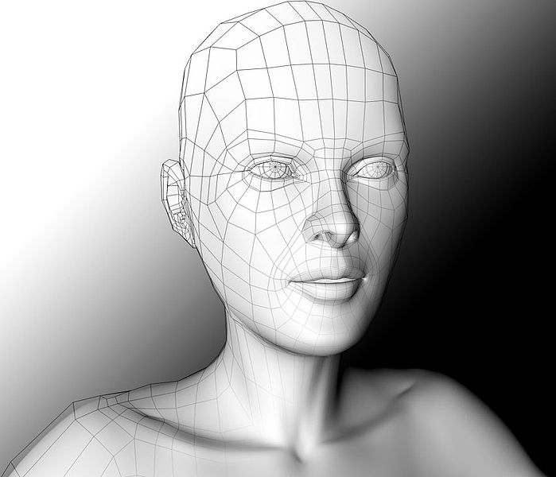
3D polygonal modeling of a human face.
There are Three popular ways to represent a model:
- Polygonal modeling - Points in 3D space, called vertices, are connected by line segments to form a polygonal mesh. The vast majority of 3D models today are built as textured polygonal models, because they are flexible and because computers can render them so quickly. However, polygons are planar and can only approximate curved surfaces using many polygons.
- Curve modeling - Surfaces are defined by curves, which are influenced by weighted control points. The curve follows (but does not necessarily interpolate) the points. Increasing the weight for a point will pull the curve closer to that point. Curve types include Nonuniform rational B-spline (NURBS), Splines, Patches and geometric primitives
- Digital sculpting - Still a fairly new method of modeling, 3D sculpting has become very popular in the few short years it has been around.[citation needed] There are currently 3 types of digital sculpting: Displacement, which is the most widely used among applications at this moment, volumetric and dynamic tessellation. Displacement uses a dense model (often generated by Subdivision surfaces of a polygon control mesh) and stores new locations for the vertex positions through use of a 32bit image map that stores the adjusted locations. Volumetric which is based loosely on Voxels has similar capabilities as displacement but does not suffer from polygon stretching when there are not enough polygons in a region to achieve a deformation. Dynamic tesselation Is similar to Voxel but divides the surface using triangulation to maintain a smooth surface and allow finer details. These methods allow for very artistic exploration as the model will have a new topology created over it once the models form and possibly details have been sculpted. The new mesh will usually have the original high resolution mesh information transferred into displacement data or normal map data if for a game engine.The modeling stage consists of shaping individual objects that are later used in the scene. There are a number of modeling techniques, including:
- constructive solid geometry
- implicit surfaces
- subdivision surfaces

Modeling can be performed by means of a dedicated program (e.g., form•Z, Maya, 3DS Max, Blender, Lightwave, Modo, solidThinking) or an application component (Shaper, Lofter in 3DS Max) or some scene description language (as in POV-Ray). In some cases, there is no strict distinction between these phases; in such cases modeling is just part of the scene creation process (this is the case, for example, with Caligari trueSpace and Realsoft 3D).

Complex materials such as blowing sand, clouds, and liquid sprays are modeled with particle systems, and are a mass of 3D coordinates which have either points, polygons, texture splats, or sprites assigned to them.

Compared to 2D Methods
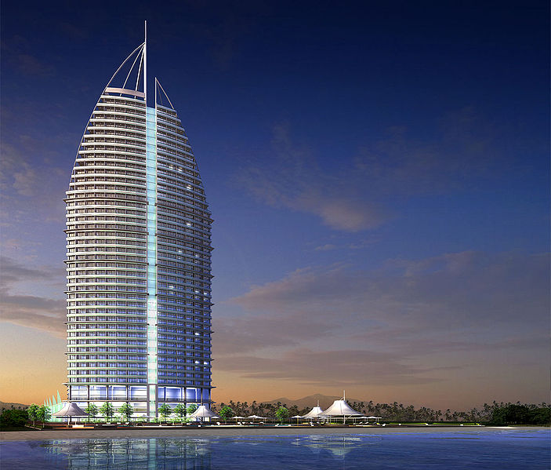
A fully textured and lit rendering of a 3D model.
3D photorealistic effects are often achieved without wireframe modeling and are sometimes indistinguishable in the final form. Some graphic art software includes filters that can be applied to 2D vector graphics or 2D raster graphics on transparent layers.
Advantages of wireframe 3D modeling over exclusively 2D methods include:
- Flexibility, ability to change angles or animate images with quicker rendering of the changes;
- Ease of rendering, automatic calculation and rendering photorealistic effects rather than mentally visualizing or estimating;
- Accurate photorealism, less chance of human error in misplacing, overdoing, or forgetting to include a visual effect.

Disadvantages compare to 2D photorealistic rendering may include a software learning curve and difficulty achieving certain photorealistic effects. Some photorealistic effects may be achieved with special rendering filters included in the 3D modeling software. For the best of both worlds, some artists use a combination of 3D modeling followed by editing the 2D computer-rendered images from the 3D model.

3D Model Market

A large market for 3D models (as well as 3D-related content, such as textures, scripts, etc.) still exists - either for individual models or large collections. Online marketplaces for 3D content, such as TurboSquid and DAZ 3D, allow individual artists to sell content that they have created. Often, the artists' goal is to get additional value out of assets they have previously created for projects. By doing so, artists can earn more money out of their old content, and companies can save money by buying pre-made models instead of paying an employee to create one from scratch. These marketplaces typically split the sale between themselves and the artist that created the asset, often in a roughly 50-50 split. In most cases, the artist retains ownership of the 3d model; the customer only buys the right to use and present the model.[3]

3D Printing

3D printing is a form of additive manufacturing technology where a three dimensional object is created by laying down successive layers of material.

Human Models
The first widely available commercial application of human Virtual Models appeared in 1998 on the Lands' End web site. The human Virtual Models were created by the company My Virtual Model Inc. and enabled users to create a model of themselves and try on 3D clothing. There are several modern programs that allow for the creation of virtual human models (Poser being one example).

Computer modelling
A theory has only the alternative of being right or wrong. A model has a third possibility; it may be right, but irrelevant.
Manfred Egan
If you put tomfoolery into a computer, nothing comes out of it but tomfoolery. But this tomfoolery, having passed through a very expensive machine, is somehow ennobled and no-one dares criticize it.
Pierre Gallois
This is one of the most powerful tools available to science and engineering and, like all powerful tools, it brings dangers as well as benefits. Andrew Donald Booth said “Every system is its own best analogue”. As a scientist he should, of course, have said in what sense he means best. The statement is true in terms of accuracy but not in terms of utility. If you want to determine the optimum shape for the members of a bridge structure, for example, you cannot build half a dozen bridges and test them to destruction, but you can try large numbers of variations in a computer model. Computers allow us to optimise designs in ways that were unavailable in times past. Nevertheless, the very flexibility of a computer program, the ease with which a glib algorithm can be implemented with a few lines of code and the difficulty of fully understanding its implications can pave the path to Cloud Cuckoo Land.

Definition of computer model
- Computer modeling is the use of computers to model objects and to simulate processes
- A computer model, or a computational model is a computer program, or network of computers, that attempts to simulate an abstract model of a particular system.
en.wikipedia.org/wiki/Computer_models

Definition of Computer Simulation
Computer simulations have become a useful part of mathematical modeling of many natural systems in physics (computational physics), astrophysics, chemistry and biology, human systems in economics, psychology, social science, and engineering. Simulation of a system is represented as the running of the system's model. It can be used to explore and gain new insights into new technology, and to estimate the performance of systems too complex for analytical solutions.
- River forecast models estimate the amount of runoff a rain event will generate. It also computes how the water will move downstream from one ...
www.weather.com/encyclopedia/flood/data.html
- Observations, experiments, and theory used to construct and refine computer models and develop scientific explanations lead to better ...
serc.carleton.edu/admin/manage/view_vocab.php

hazards of computer modeling
The main hazards of computer modeling can be summarized under a few headings:
Assumptions
At almost every stage in the development of a model it is necessary to make assumptions, perhaps hundreds of them. These might or might not be considered reasonable by others in the field, but they rapidly become hidden. Some of the larger models of recent times deal with the interactions of variables whose very nature is virtually unknown to science.
Auditability
In olden times, if a scientist published a theory, all the stages of reasoning that led to it could be critically examined by other scientists. With a computer model, it is possible, within a few days of development, for it to become so complex that it is a virtual impossibility for an outsider to understand it fully. Indeed, where it is the result of a team effort, it becomes unlikely that any individual understands it.
Omissions
Often vital elements can be left out of a model and the effect of the omissions is only realized if and when it is tested against reality. A notorious example is the Millennium Bridge in London. It was only after it was built and people started to walk on it that the engineers realized that they had created a resonant structure. This could have been modeled dynamically if they had thought about it. Some models that produce profound political and economic consequences have never faced such a challenge.
Subconscious
The human subconscious is a powerful force. Even in relatively simple physical measurements it has been shown that the results can be affected by the desires and expectations of the experimenter. In a large computer model this effect can be multiplied a thousandfold. Naturally, we discount the possibility of deliberate fraud.
Sophistication
This word, which literally means falsification or adulteration, has come to mean advanced and efficient. In large computer models, however, the literal meaning is often more applicable. The structure simply becomes too large and complex for the inputs that support it.
Testability
When we were pioneering the applications of computer modelling about forty years ago, we soon came to the conclusion that a model is useless unless it can be tested against reality. If a model gives a reasonably accurate prediction on a simple system then we have reasonable, but not irrefutable, grounds for believing it to be accurate in other circumstances. Unfortunately, this is one of the truisms that have been lost in the enthusiasms of the new age.
Chaos
Large models are often chaotic, which means that very small changes in the input variables produce very large changes in the output variables. Some very simple processes can amplify errors, taking the difference between numbers of a similar magnitude for example. The errors (or noise) are then propagated through the system. If there are feedback mechanisms present, it is quite possible for systems to operate on the noise alone.
Many of the computer models that receive great media coverage and political endorsement fail under some of these headings; and , indeed, some fail under all of them. Yet they are used as the excuse for profound, and often extremely damaging, policies that affect everyone.
That is why computer models are dangerous tools.

Value of Computer modeling
Computer models are valuable because they:
- Allow a person to study the response of a system to conditions that are not easily or safely applied in a real situation.
- Can be speed up or slowed down.
- A model can also allow an observer to study how the functioning of an entire system can be altered by changing individual components of the system.

How Computer models are built:
- A computer model is usually defined in mathematical terms with a computer program .
- Mathematical equations are constructed that represent functional relationships within a system.
- When the program is running the mathematical dynamics become analogous to dynamics of the real system.
- Results are given in the form of data.
- Some types of model involve a computer graphics representation of an object, which can be manipulated on a video display terminal in much the same way that a three-dimensional clay or wood model might be manipulated.
- The success of computer models is highly dependent on the mathematical representations of systems and on chosen input parameters.
- For many systems, graphical or mathematical representations are extremely complex because there are so many factors present. Factors are often represented as sub-models, and interact with each other. Input parameters consist of conditions that are known at the beginning of a modeling sequence and often have to be estimated.

Application of computer Models:
The variety of computer models increased as computers have become larger and faster. The increasing powers of computers will make computer models ever more useful, for research, for business planning, and for personal applications. With new generations of supercomputers, it should become more feasible to construct more accurate models of extremely complex systems, such as the weather, stellar evolution, and fundamental particle interaction. However, right now, the major fields of modeling application are:
- Economic models:
Those are now used to study economic growth, employment, energy and food resources, population, and housing needs, on a world scale as well as on a local level.
- Environmental systems:
Many environmental systems have been modeled. The effect on soil and water of chemical or nuclear contamination can be evaluated with a computer. A model of a river can show how using water for dams, irrigation, and power plants will affect the water flow at various points. Computer models can help in studying soil erosion and planning commercial use of forest land.
- Medical Models:
In the medical field, computer models are used to develop new drugs and to predict their effects on the body. Three-dimensional models of human organs are used to teach anatomy and biology to medical students, with the advantage that the student can manipulate the computer model like a real object, while graphics and animation reveal otherwise hidden information. Neural networks, computer approximations of the brain's neural architecture, aid researchers in understanding brain functions.
- In engineering,
Most designs are developed and tested with a computer model . With interactive computer-aided design, engineers draw and redraw designs quickly and inexpensively. Not only does the computer aid in the design, it also allows the user to study the response of the designed product to factors such as physical stress. The engineer can also study the effects of different materials on physical properties, and the effects of different designs on cost.
- In business concerns,
Spreadsheet programs are simple and inexpensive computer models that are widely applicable, especially when accompanied by graphs and charts. As an example, they can be used to study how changes in levels of sales and prices effect a company's profits.

